**Programming Assignment 2 :** **PROGOL**

**CS6364**

Submitted by :

Aashaar Panchalan – adp170630

Manish Biyani

**Ex. 1:**

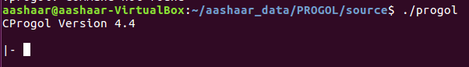

**Ex. 2:**

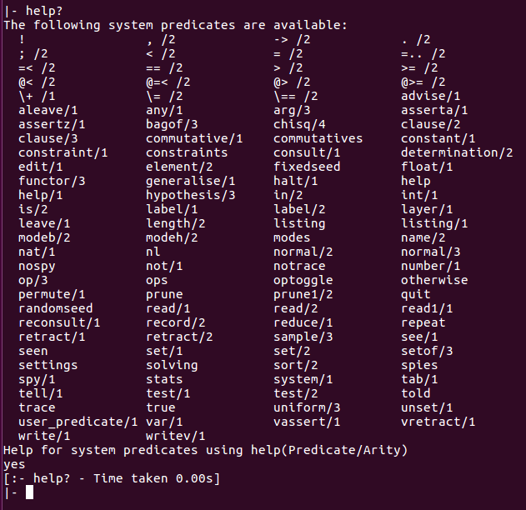

**Ex. 3:**

Please refer the file ‘adder.pl’ in the codes folder, for the code.

Here’s the screenshot for input state : a, not_b, not_c_in:

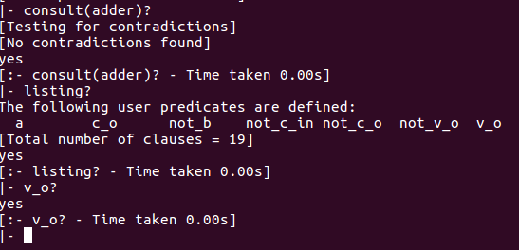

**Ex. 4:**

**a)**

|  |  |  |  |  |  |
| --- | --- | --- | --- | --- | --- |
| **A** | **B** | **Cin** | **Vo** | **Co** | **Progol Screenshot** |
| 0 | 0 | 0 | 0 | 0 |  |
| 0 | 0 | 1 | 1 | 0 |  |
| 0 | 1 | 0 | 1 | 0 |  |
| 0 | 1 | 1 | 0 | 1 |  |
| 1 | 0 | 0 | 1 | 0 |  |
| 1 | 0 | 1 | 0 | 1 |  |
| 1 | 1 | 0 | 0 | 1 |  |
| 1 | 1 | 1 | 1 | 1 |  |

From the truth-table, we have verified that Progol gives correct answers for all the output propositions.

**b)**

Yes, the adder circuit can be represented by fewer clauses by eliminating the negation of the two outputs. If we have the propositions for v_o and c_o we don’t need to maintain not_v_o and not_c_o. if required, they can simply be obtained by negating the v_o & c_o respt. Thus we can eliminate 8 clauses and the same adder circuit can be formed using only 8 clauses – 4 each for v_o and c_o.

**Ex. 5:**

Please refer the file ‘adder2.pl’ in the codes folder, for the code.

Here’s the screenshot for input state : a, c (since we require not(b) to be true, we haven’t specified ‘b’ in the file so that by closed world assumption it becomes true.):

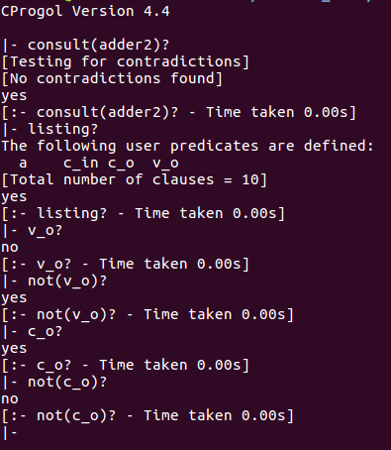

From the output in the above screenshot, we can see that not_v_o and not_c_o can be derived from the the v_o and c_o respt., simply by negating them due to the closed world assumption.

**b)**

|  |  |  |  |  |  |
| --- | --- | --- | --- | --- | --- |
| **A** | **B** | **Cin** | **Vo** | **Co** | **Progol Screenshot** |
| 0 | 0 | 0 | 0 | 0 |  |
| 0 | 0 | 1 | 1 | 0 |  |
| 0 | 1 | 0 | 1 | 0 |  |
| 0 | 1 | 1 | 0 | 1 |  |
| 1 | 0 | 0 | 1 | 0 |  |
| 1 | 0 | 1 | 0 | 1 |  |
| 1 | 1 | 0 | 0 | 1 |  |
| 1 | 1 | 1 | 1 | 1 |  |

From the truth-table, we have verified that Progol gives correct answers for all the output propositions.